# *Web Programming I (420-H10-HR)*

# *Lab 5 – Images & Backgrounds*

Date due: **Thursday, September 24, 2020, at the end of your lab.**

**Learning Objectives**

Upon successful completion of this lab exercise, the student will be able to:

* Add images and background images to a web page

To do:

**Lab Set-Up**

1. Copy the H10L05_Files zip file from Moodle and unzip it to your H:\420-H10\Labs folder. Rename the folder to **YourUserName_H10L05**.
2. Remember to save and test the pages often. Do not attempt to make all the required changes and then save your work.
3. Use Visual Studio Code effectively when creating your websites. There are two (many actually, but I’ll start with two) things you can do.
4. Use Open Folder to open a folder in Visual Studio Code. To do this go to File **»** Open Folder and browse to find the folder you created in Step 1 above. That way you will have easier access to your files and be able to use the next step correctly.  
   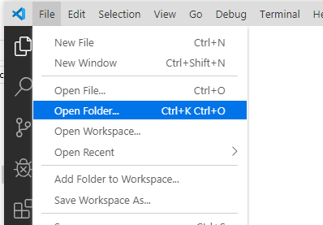
5. Open your files in Live Server. When you have an HTML document in view you can right click and choose Open with Live Server. This will open up your default browser (or Chrome) and run a virtual web server. Then any changes you save in either your HTML or CSS files will be reflected in the browser immediately without having to refresh.
6. **YOU CAN ONLY USE THE HTML AND CSS THAT YOU HAVE LEARNED SO FAR IN WEB I FOR THIS LAB. YOU CANNOT USE ANY OTHER CSS.**
7. ONLY EXTERNAL CSS IS ALLOWED IN THIS LAB. YOU MUST DO ALL FORMATTING IN THE EXTERNAL CSS (no <em> or <strong> tags, etc).

**To Do:**

1. Create a new HTML file called simpleImage.html. Make sure you add an appropriate title.
   1. Add the image htmlcss.jpg to the file. The image is found in the images subfolder. Make sure you include the 4 important attributes on the image tag as discussed in class. The initial image is 600px wide and 400px in height.
   2. Add a couple of line breaks (or use a different div) to add the same image again, but at half the default size.
   3. Repeat step b but make the image twice the default size.
   4. After step (a) the page looks like:

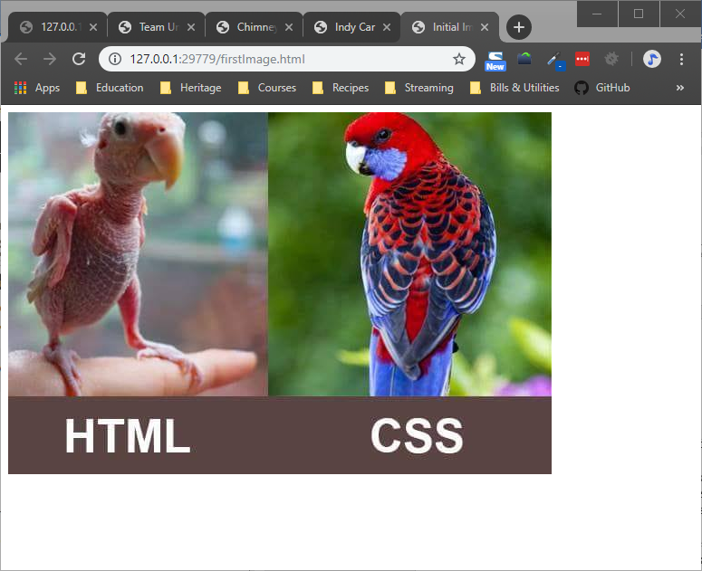

1. In this exercise you will add a background image to the document body of a web page for a chimney repair company.
   1. Open the chimneyrepair.html file in the editor. If you opened the folder in VS Code this will be much easier. The chimney.gif file is in the images folder.
   2. Create and attach a stylesheet called ChimneyRepair.css in the styles folder.
   3. Move the CSS declarations included in the HTML file to the external CSS file and remove the <style> tag from the HTML document.
   4. Add the appropriate style declaration to the body element that will place the chimney.gif image in the document’s background. The image should repeat.
   5. The result looks like:



1. Open the empty web page called superhero.html. Also open the text file superhero.txt. The text file contains the name, a summary and a list of some enemies and allies of 5 Marvel superheroes (why Marvel, because DC, by and large, sucks). There is an image of each of these superheroes in the images folder. Modify superhero.html as follows
   1. Use a linear gradient background of two colours starting with a darker colour on top and a lighter colour at the bottom;
   2. Add a first level header with the background image using the image marvel.png displayed on the left hand side of the h1 tag and not repeated. Next to the log add the words Top Characters. Put a rounded border (try 20px) around the h1 tag.
   3. For each hero, create a separate div/section/element. Include in each one
      1. The hero’s name in an <h2> tag;
      2. The image of the superhero from the images folder;
      3. The description of the hero (from the file);
      4. An unordered list of their allies and a second unordered list of their enemies. The lists CANNOT use the default list style tag but must use something different.

I am purposely not telling you how this page should look, but you MUST adhere to good design principles using proper font, different HTML elements and CSS as appropriate. For example, the superheroes name could be in a different colour or the border could be a different colour.

1. In this exercise we are going to do some more work on backgrounds.
   1. Open the page called indycar.html.
   2. Attach a new external stylesheet to the page called indycar.css. Make sure to place the css file in the styles folder.
   3. Add a rule for the body of the page which sets the font-family to Verdana, Arial or sans-serif and the background colour to black (#000000)
   4. Add a rule for an id called wrapper which sets the width to 90% and centres the page by setting the margin-left and margin-right values as we discussed in class and you did in last week’s lab. Add a background colour of #D3D3D3.
   5. Add a rule for the h1 tag to set the line height to 250%, the width to 80% the font colour to #fe9a58 and the background colour to #5e5e5e. Finally set the font-style to oblique.

At this point the page should look like this:

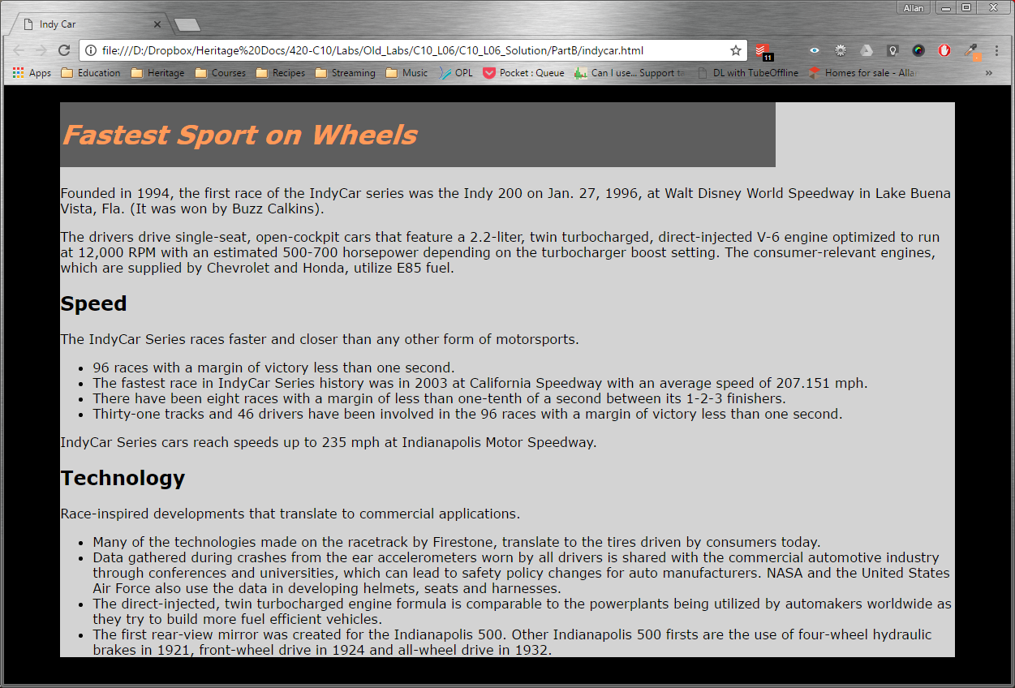

Now we will add some background images.

* 1. Add the background image backspeed.jpg from the images folder as the background image for the body.
  2. Add the background image indycar.png from the images folder as the background image for the h1 tag. Set this image so that it positioned to the right and does not repeat.
  3. Add the background image trophy.png from the images folder as the background image for the wrapper div. Set this image so that it is positioned to the center right and does not repeat.

The page should now look like this:

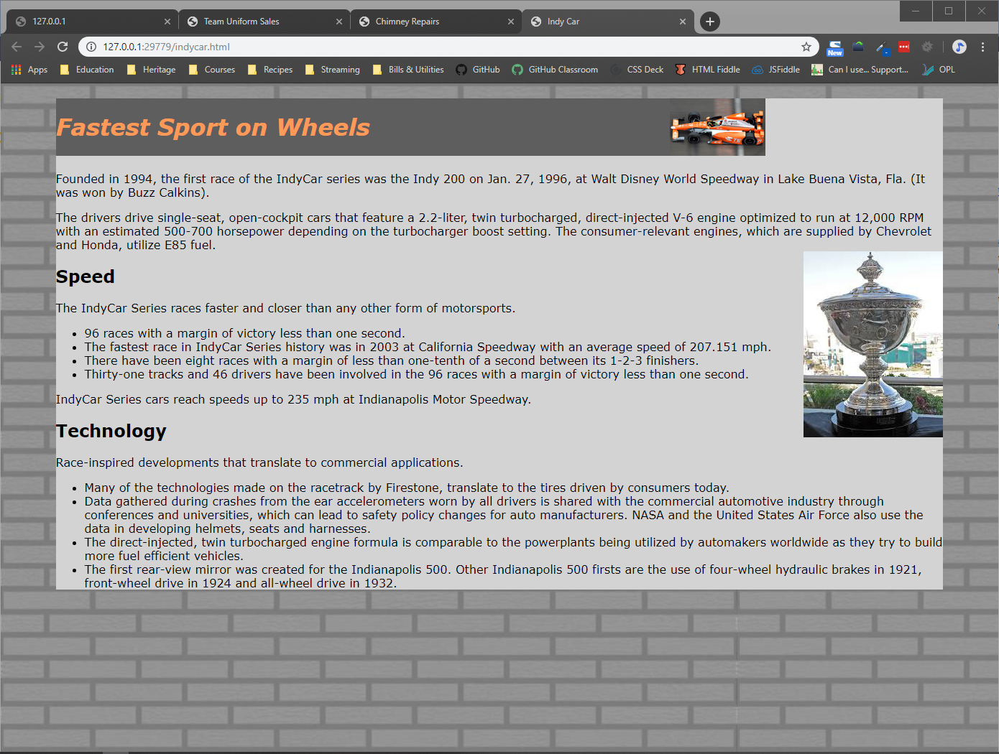

1. We cannot cover everything in class, so some things will be covered in the lab through some more interesting exercises with CSS. Today we will spend some time with the CSS filter property.
   1. Open the file roses.html and the associated roses.css file. I have already set up some basic CSS in the file. You are going to add some CSS to create a background effect for a portion of the page.
   2. Let’s start by changing the background colour for the body of the page. Make the background colour #5e703b and the font colour #ffffff. The page will look like this:  
      
   3. Now we are going to change the background of the aside element. At the bottom of the CSS file, the aside element (inside the main element) is defined simply to have a height of 50vh. Add a background colour using rgba of black (0,0,0) and an alpha value of .3. Now the page is like this:  
      
   4. Next add a background image of the aside to the image crocus.png from the images folder. Set the background to not repeat. Now we have this:  
      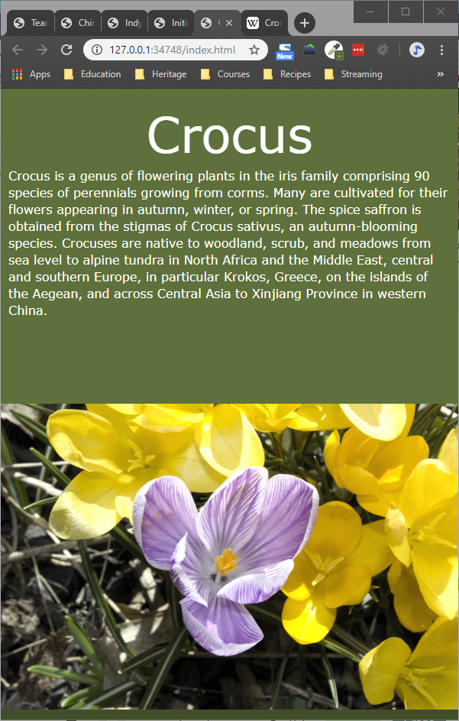  
      Which is pretty good, but we are going to stylize it a bit more.
   5. The CSS filter property is a powerful property that allows you to add various filters to a page with varying impact. Usually filters are applied to images of backgrounds. There are a number of filters that can be applied in including blurring, contrast, brightness, sepia, grayscale, etc. Today we are going to work with grayscale. Feel free to try some of the others if you like. A good reference is: <https://css-tricks.com/almanac/properties/f/filter/>
   6. For now, go back to the aside property in the CSS file and add filter: grayscale(100%) which means completely to grayscale. Now the HTML page looks like this:  
      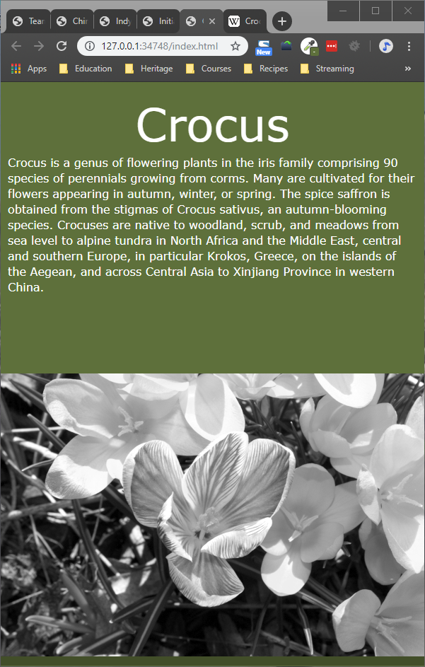
   7. To allow the image to blend more with the page, we are going to allow some of the background of the aside to come through the image. To do this, add an opacity of .3 to the aside element. The final page should look like this:  
      

NOTE: You need to make the browser quite narrow to see this properly. In the coming weeks we will learn a better way to do this by placing the image to the side of article element.

NOTE 2: Yes I know 50vh and 45 vh does not equal 100vh. We will also see why this is in the next couple of weeks when we talk about the box model.

Remember: You MUST validate both the external CSS file and the html file using the appropriate w3c validators. It is the first thing I will do when I mark them.

**To submit**

When you have completed the lab exercise, show me your work and then copy the files from the YourUserName_H10L05 folder (listed below), to the Moodle area for this course:

* The folder (with all the files)